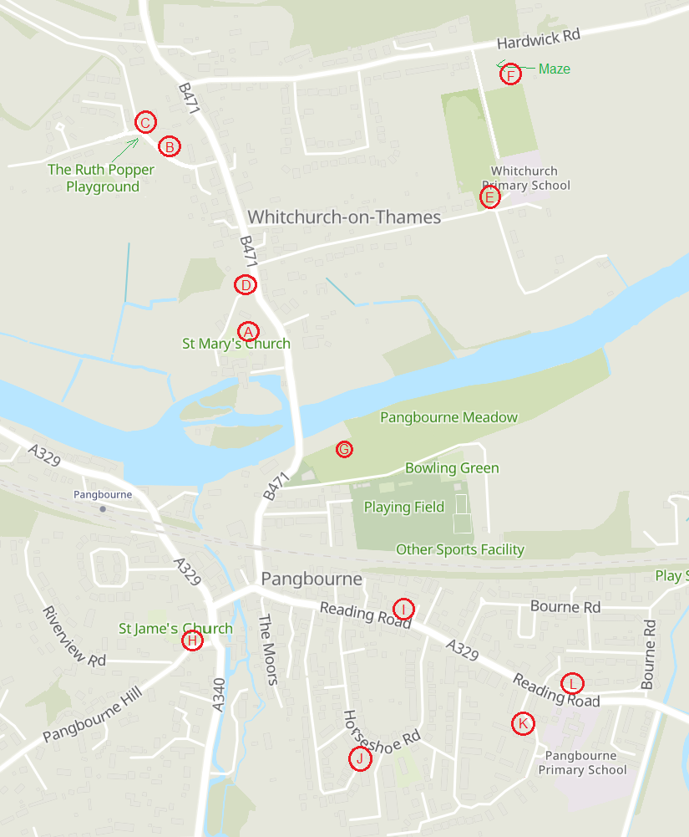MAP OF PANGBOURNE & WHITCHURCH SHOWING LOCATION OF THE 12 TREES (marked with letters A to L)

Tree Trail

in Pangbourne & Whitchurch

Do you know the names of the trees that are growing in our villages? Can you tell the difference between an Oak tree and a Beech tree?

This tree trail will test your knowledge and should encourage you to look more closely at them.

**How to follow the Trail**

When the leaves are on the trees, walk around Pangbourne and Whitchurch, going to the 12 places which are marked on the map on the back page of this leaflet. Each location is marked with a letter, from ‘A’ to ‘L’. It doesn’t matter what order you walk from location to location, or how long it takes you (it isn’t a race!).

When you get to each place, read the ‘Helpful Hints’ which will help you pinpoint the exact tree you should be identifying. Now read through the list of 12 tree species on the Answer Sheet and look at the ‘Helpful Pictures’. When you have decided which tree you have found, write down the location reference (letter) next to the name of the tree on your Answer Sheet.

When you have located all the 12 trees, you can check your answers by visiting the PAWS website (<https://pawsg.com>) or by calling in at Garlands Organic or Pangbourne Library (both on Reading Road, Pangbourne) for a printed copy of the answers.

*Contact the PAWS group on* [***pawsg21@gmail.com***](mailto:pawsg21@gmail.com)*fo****r*** *any further information about this Trail, or any comments about the trees you have seen on your walk.*

***The production of this leaflet was supported by***

***a grant from the Pangbourne Rotary Club***

HELPFUL HINTS - for finding the trees

A - This tree is prominent, with gravestones underneath, and is on your left as you walk towards the church doorway

B – These trees are in a row on the grassy verge, on the right as you walk up Manor Rd towards the playground

C – These trees are in a group of 4, very close to and on the right of the gated entrance to Coombe Park

D – This tree is tall and is growing just behind the wall marked ‘Private Drive to Walliscote House’ (also the way to the church)

E – This tree is also tall and is growing about halfway along in the hedge, on the left of the drive to the Primary School

F – This is a small thorny tree with a lot of lichen growing on it, and is in the corner near the alpaca field

G – There are two of these trees close together near the horizontal tree trunk

H – This tree guards the main door of St James The Less church

I – These two trees are growing one each side of the entrance to Pangbourne Day Nursery

J – This tree is on the left-hand corner of the entrance to Horseshoe Park

K – This spreading tree shades house No.105 Kennedy Drive

L – Several of these trees grow on the wide grassy verge opposite Pangbourne Primary School. (Note: they are not fruit trees, although they sound as if they are!)

HELPFUL PICTURES - for identifying the trees

|  |  |  |
| --- | --- | --- |
|  |  |  |
| Beech | Catalpa | Blackthorn |
|  |  |  |
| Horse Chestnut | Lime | Oak |
|  |  |  |
| Magnolia | Silver Birch | Sycamore |
|  |  |  |
| Walnut | Willow | Yew |